

NAME : BISMA FATIMA
CLASS : CS A
ROLL NO: F24605036
COURSE : OBJECT ORIENTED PROGRAMMING
COURSE CODE : CS-123
LECTURER : MISS TAYYABA KALSOOM

INLAB TASK
LAB 02

Task 1: Odd or Even
Write a program that takes an integer input from the user and checks whether it is odd or even using a conditional statement. If the number is odd, print ”Odd”; otherwise, print ”Even”.
PROGRAM
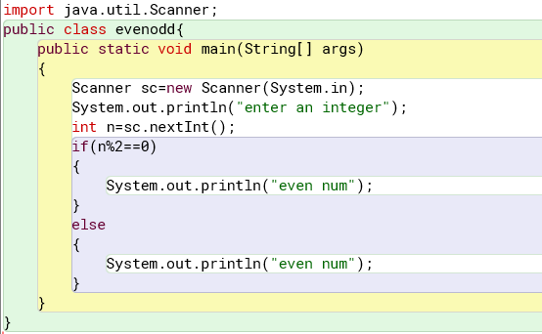

OUTPUT
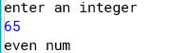

Task 2: Multiplication Table
Write a program that prints the multiplication table of a given number (input by the user) up to 10.
PROGRAM
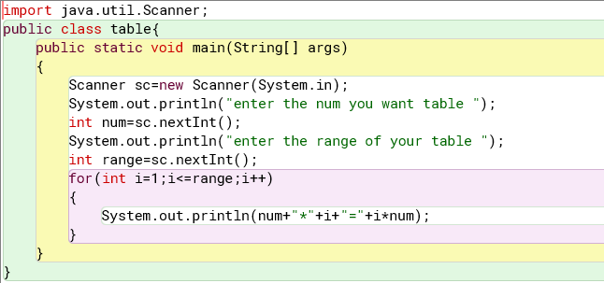

OUTPUT
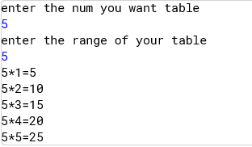
Task 3: Sum of Digits
Write a program that takes a positive integer as input and calculates the sum of its digits. For example, if the input is 1234, the output should be 10 (1 + 2 + 3 + 4).
PROGRAM
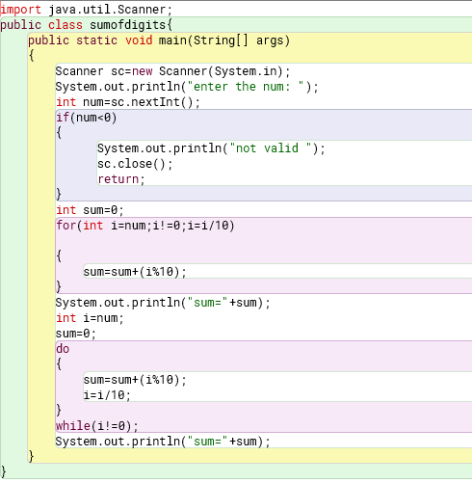

OUTPUT
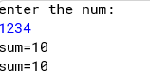

Task 4: Prime Number Checker
Write a program that checks whether a given number is prime or not. A prime number is only divisible by 1 and itself.
PROGRAM
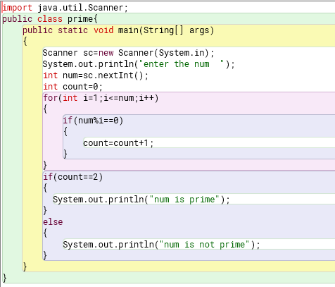
OUTPUT
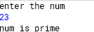

Task 5: Reverse a String
Write a program that takes a string as input and prints it in reverse order.
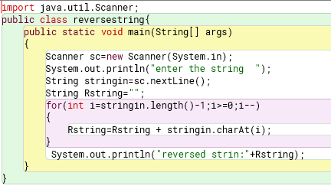
OUTPUT
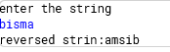
Task 6: interest calculation on the basic of age.
PROGRAM
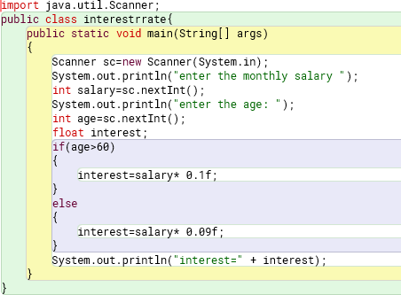
OUTPUT
